# NATIONAL ASSOCIATION OF UNIVERSITY WOMEN

Volume 4, Issue 4

January 2014

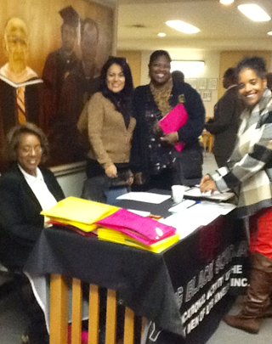

**My NAUW Culver City Sisters,**

**HAPPY NEW YEAR!!!** I am thankful to be able to start a brand new year. Now is the time to set new goals and to feel a sense of renewal. We get to start over again and perhaps not make the same mistakes that we made in the previous year.

Let’s all make a pledge this year to do better. Let’s all agree to make **NAUW** our priority for 2014 and do what we can to further the goals of this great organization.

We had a great time at our **Christmas Gala.** We sang carols, ate good food, enjoyed great fellowship, and played some games. Our thanks to the **Christmas Gala Committee – Mildred Slaughter, Dr. Claretha Graham, and Sharon L. Robinson.** A special thanks goes to **Herracia Brewer** for leading us through the games. **Mildred Slaughter** was the chair for the **Gala.** She made all the arrangements for the party but was unable to stay for the party because she was not feeling well. I am happy to report that she is doing better and feeling fine.

We were able to collect many pairs of socks to donate to the **Marvista Country Villa** (convalescent home) and the patients there. We also visited **Odessia Love,** who is now at home and doing quite well. Her physical therapy is ongoing.

The **Raffle** was held on December 8th at our **Christmas Gala**. The drawing prize was money to the ticket winners. The funds collected will be used for scholarships. The winners were as follows:

**1st Prize John Ricks $150 2nd Prize Matteal Kirby $75 3rd Prize Lola Moore $50**

Just a reminder to **Culver City members** that we will take a group picture on **Sunday, January 12, 2014.** Members are asked to **WEAR WHITE ATTIRE** and the green kente cloths if you have one. Hopefully, we will also be able to induct our newest member, **Roberta Jones** on this day as well.

Only a few more weeks to go before we have our **45th Southwest Sectional Conference which will be held at the** **Doubletree by Hilton Hotel in Torrance, California, located at 21333 Hawthorne Boulevard on January 31-February 1, 2014. The room rates are $99 per night with plenty of free parking. We want every member to register** for the Conference.The registration deadline is **January 14th for $165. After that date is late registration. The fee then is $170. On-site registration will be $175 by credit card or debit card only. No cash will be accepted.**

**All Culver City members are asked to bring their membership cards to the meeting on Sunday, January 12th to receive their current stickers.**

**The next Southwest Sectional Planning Meeting is scheduled for Thursday, January 9th, at Dulan’s Restaurant on Crenshaw.** All members are invited to attend and assist the committee as we prepare to host the **45th Southwest Sectional Conference.**

The above photo shows your President volunteering at a Young Black Scholars event on December 14th at Charles Drew University in Watts. Our own Dr. Virginia Hathaway is the Director of Young Black Scholars.

Blessings to you all,

**Helen Ricks, President**

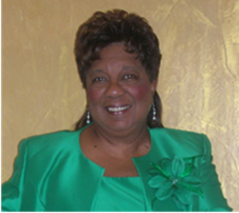

CULVER CITY STAR

## **PRESIDENT’S CORNER**

culver city nauw:

**Executive Board 2012-2014**

**President**

**Helen Ricks**

**1st Vice President**

**Mildred Slaughter**

**2nd Vice President**

**Carolyn Williams**

**Recording Secretary**

**Clarissa Andrews**

**Corresponding Secretary**

**Herracia Brewer**

**Financial Secretary**

**Hester Watkins**

**Treasurer**

**Kenya Dennis**

**Historian**

**Dr. Virginia Hathaway**

**Parliamentarian**

**Dr. Claretha Graham**

**Immediate Past President**

**Mildred Slaughter**

**SECTIONAL DIRECTOR**

**EVELYN L. WRIGHT**

**NATIONAL PRESIDENT**

**DOLORES Y. OWENS**

**NATIONAL THEME:**

**“Women Moving Forward with Purpose and Pride”**

**CULVER CITY STAR**

Page 2

## **SICK AND SHUT-IN**

Please let us continue to keep **Evelyn Wright** and her family members lifted up in your thoughts and prayers. In addition, pray for **Odessia Love**, who is at home recuperating and Carolyn Williams, who recently broke her foot.

.



.

“Do not be conformed to this world, but be transformed by the renewing of your mind, so that you may prove what the will of God is, that which is good and acceptable and perfect.”

Romans 12:2

BIRTHDAYS AND ANNIVERSARIES

**January Hostesses for January**

**Ruthie Williams 1/3 Kenya Dennis Roberta Jones 1/21 Sharon L. Robinson Evelyn Wright**

**February Evelyn Wright 2/4**

**Evelyn Wright 2/4**



**45th Southwest Sectional Conference January 31- February 1, 2014**

**Mailing Address**: NAUW Culver City Branch P.O. Box 2524 Culver City CA 90231-2524

News articles are due by January 1, 2014, for the next newsletter.

**Membership dues are to be paid by September 30th. After October 1, there is a late fee.**



### **Dates to Remember**